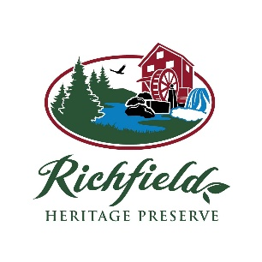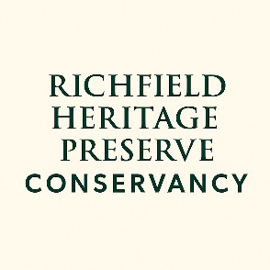
A new opportunity to support the Richfield Heritage Preserve is here! The Richfield Joint Recreation District announced at its October 26, 2025 meeting the launch of the Richfield Heritage Preserve Conservancy, a 501(c)(3) nonprofit dedicated to support the operation of park lands owned or operated by the Richfield Joint Recreation District. This designation means: donations to the RHP Conservancy are tax-deductible, the RHP Conservancy can pursue grants and funding sources, and donor gifts help shape the future of Richfield Heritage Preserve – today and for generations to come. Whether you love the trails, the wildlife, the quite, or the community it brings together – this is your chance to invest in what makes RHP special. Donor support helps sustain and improve this space for generations to come.
Donate. Share. Be a part of the story.
Contact Park-director@rjrd.org for more information.

